LAB # 09

Introduction to HTML Forms and CSS Basics


Fall 2022
CSE101L Computer Fundamentals Lab

Submitted by: Haris Khan
Registration No. : 60032
Class Section: A

“On my honor, as student of University of Engineering and Technology, I have neither given nor received unauthorized assistance on this academic work.”

Student Signature: ______________

Submitted to:
Engr. Abdullah Hamid
January 10, 2023

Department of Computer Systems Engineering
University of Engineering and Technology, Peshawar

Step#01:
I coded an HTML and CSS for the given topic.
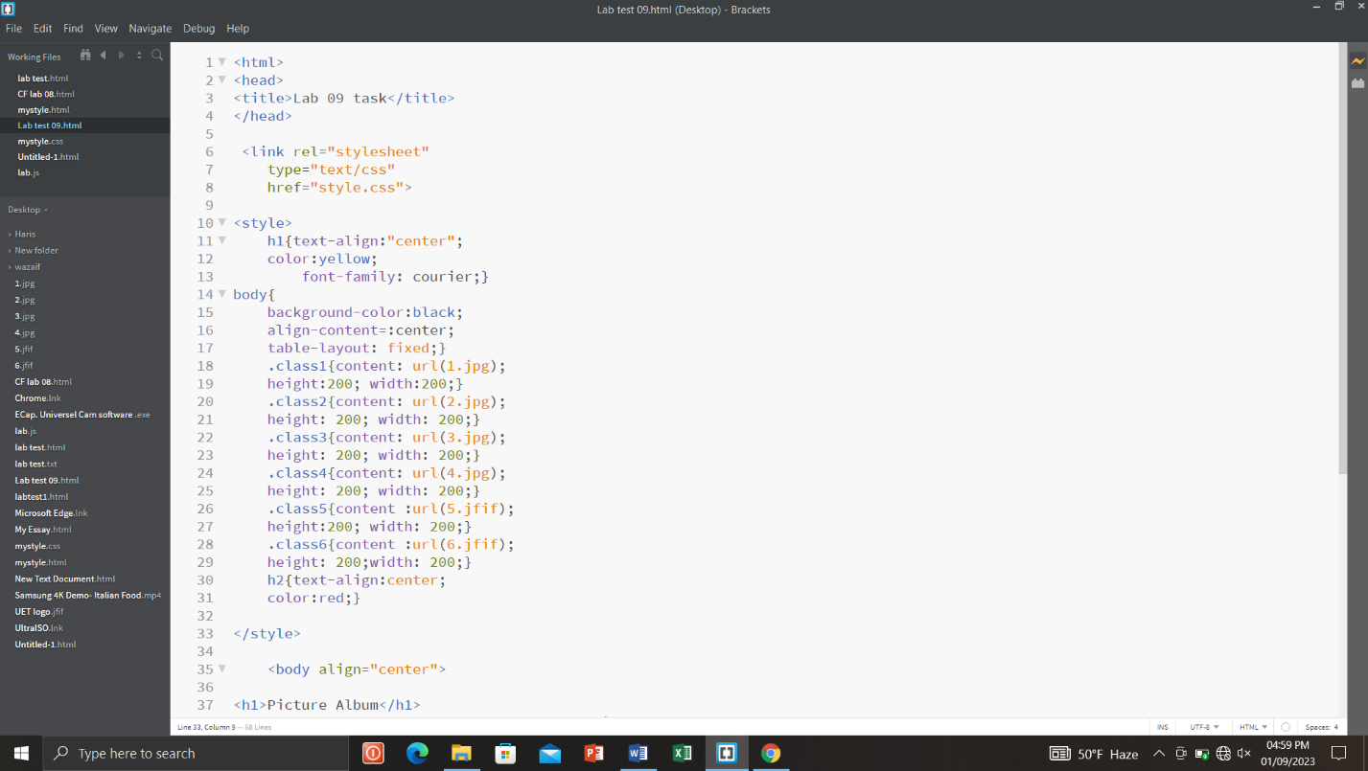
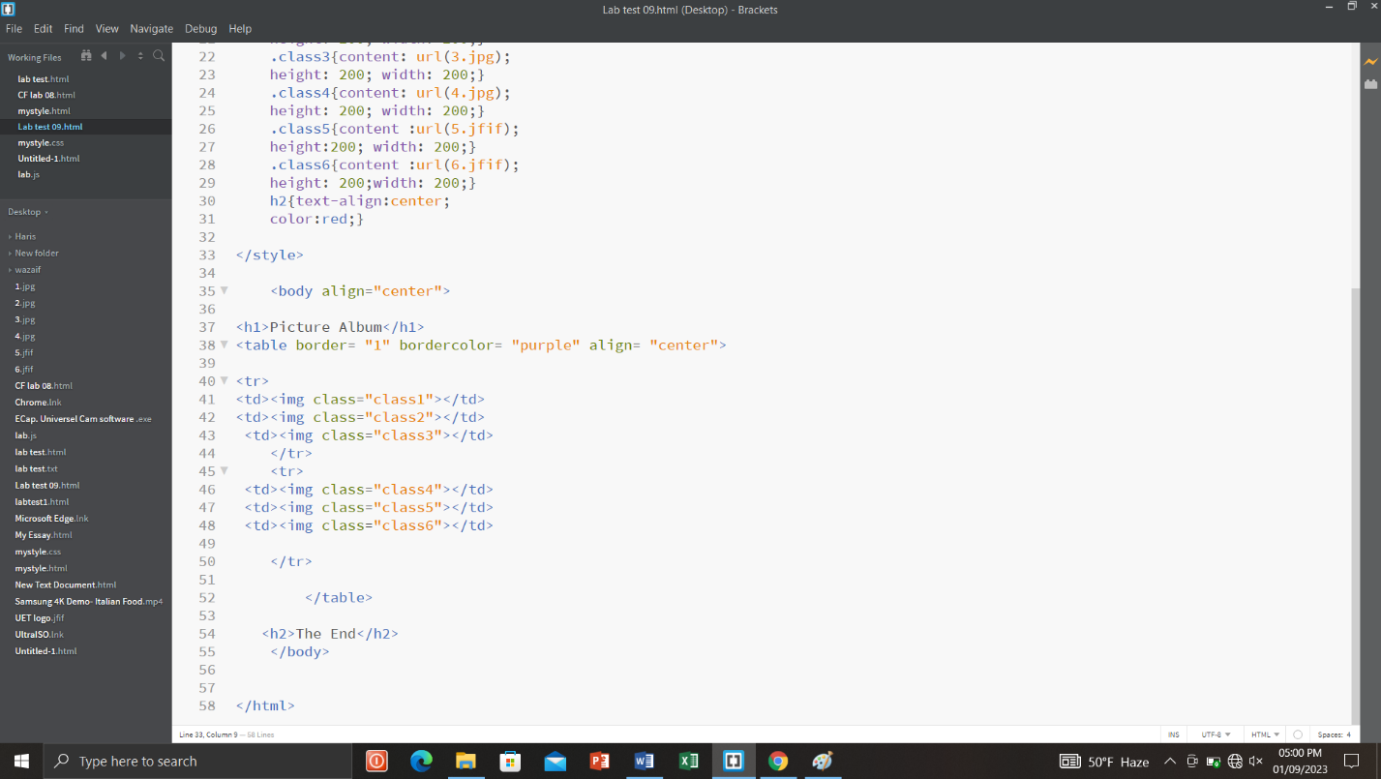

Step#02:
I ran the program in the browser.
